**Project Design Phase**

**Problem – Solution Fit Template**

|  |  |
| --- | --- |
| Date | 8 February 2026 |
| Team ID | LTVIP2026TMIDS26598 |
| Project Name | Prevent User Deletion If Assigned to Incident |
| Maximum Marks | 2 Marks |

**Problem – Solution Fit Template:**

In IT Service Management systems like ServiceNow, administrators often face issues such as:

• Users who are assigned to active incidents being accidentally deleted.  
• Loss of incident ownership when assigned users are removed.  
• Workflow disruption due to broken references between User and Incident tables.  
• Data inconsistency affecting reporting and accountability.  
• Manual monitoring required to prevent risky deletions.

This creates operational risk and reduces system reliability.

**Purpose:**

The **Prevent User Deletion If Assigned to Incident** project addresses this issue by:

• Implementing a **Before Delete Business Rule** on the sys_user table.  
• Automatically checking the incident table using GlideRecord before deletion.  
• Blocking deletion if the user is assigned to one or more incidents.  
• Displaying a clear error message to the administrator.  
• Ensuring data integrity and workflow continuity within ServiceNow.

# Solution Fit:

This solution:

• Prevents accidental deletion of critical user records.  
• Maintains proper incident ownership.  
• Protects system workflow and reporting accuracy.  
• Reduces manual administrative effort.  
• Strengthens ServiceNow data governance and reliability.

**Template:**

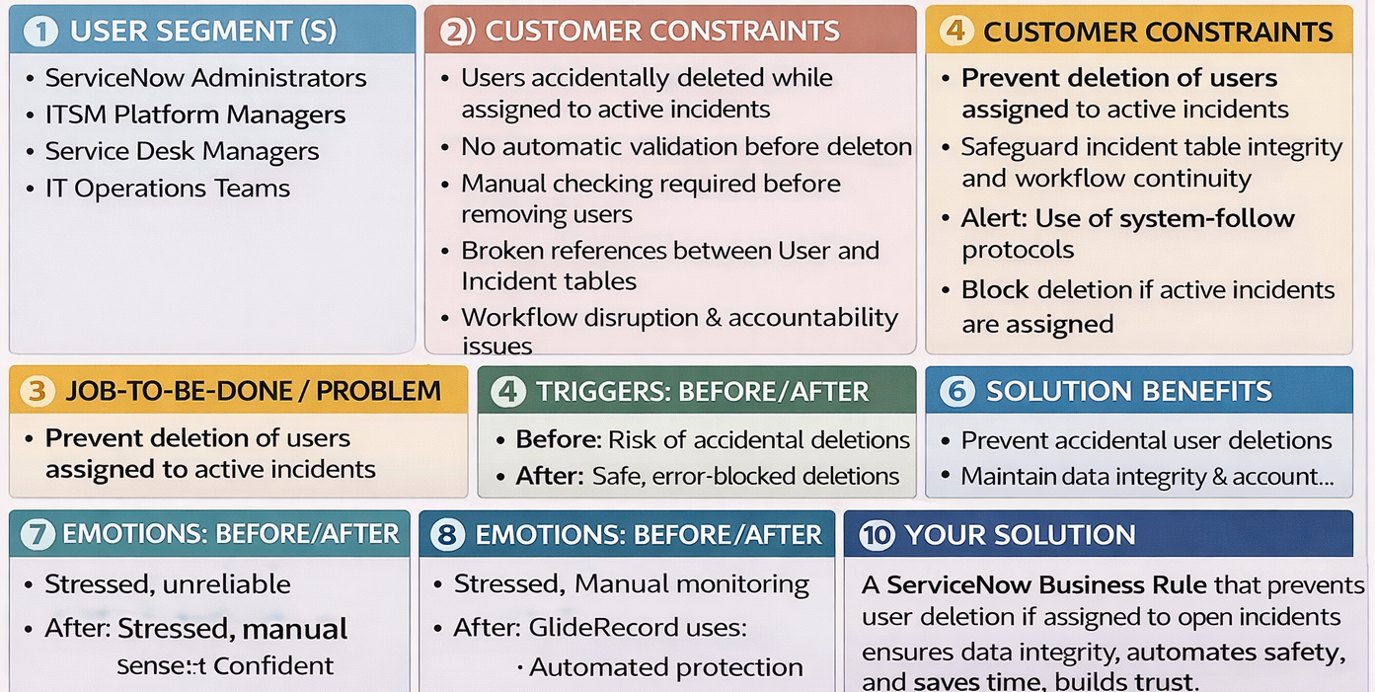

References:

1. <https://www.ideahackers.network/problem-solution-fit-canvas/>
2. <https://medium.com/@epicantus/problem-solution-fit-canvas-aa3dd59cb4fe>